**SME Explanation: REST Country Web Service in Spring Boot**

**1. What happens in the controller method?**

In the controller method getCountryIndia(), when a user accesses the ‘/country’ URL, Spring Boot maps the request using the @RequestMapping annotation. The method then loads the country.xml file from the resources folder using the *ClassPathXmlApplicationContext*. From this XML file, it fetches the bean with ID "in" which represents the country, India. This bean is an instance of the Country class and contains the values "IN" for code and "India" for name. Finally, the method returns this Country object as the HTTP response.

**2. How the bean is converted into JSON response?**

The conversion of the bean to a JSON response is handled automatically by Spring Boot. Since the controller is annotated with @RestController, any object returned from a handler method is automatically converted into JSON using the Jackson library, which Spring Boot includes by default. Jackson serializes the Country object into a JSON structure with keys code and name, and the Content-Type header of the response is set to application/json. This makes the response easily consumable by clients such as browsers or Postman.

**3. In network tab of developer tools show the HTTP header details received**

When the ‘/country’ endpoint is accessed through a web browser like Chrome, the Developer Tools can be used to inspect the HTTP response. In the Network tab, clicking on the ‘/country’ request reveals the request and response headers. The Request Headers typically include details like GET /country HTTP/1.1, Host: localhost:8083, and Accept: application/json. The Response Headers include Content-Type: application/json, indicating the format of the data returned, along with Content-Length, Date, and sometimes Server.

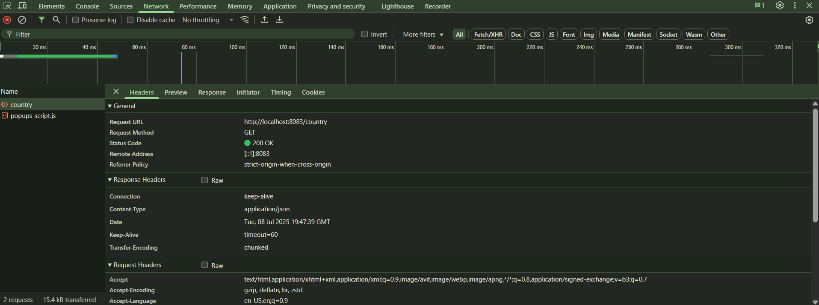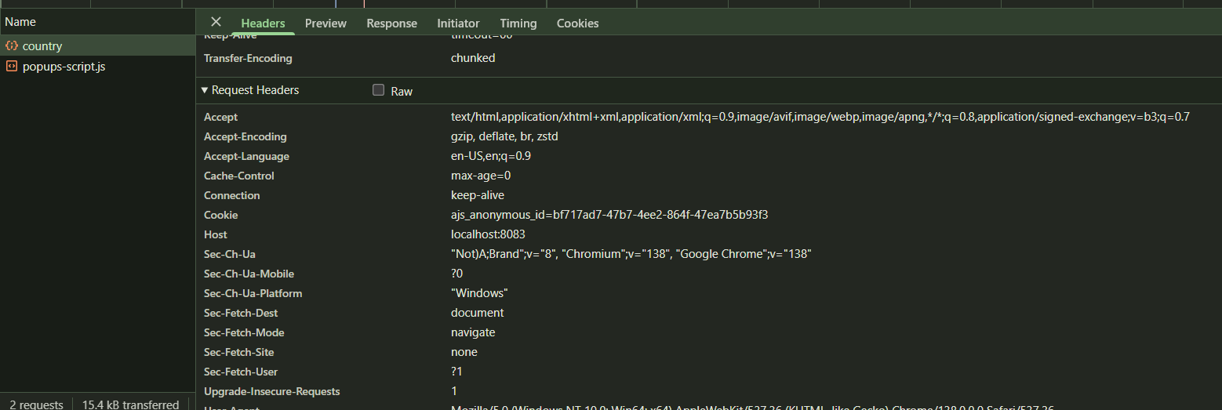

**4. In Postman click on "Headers" tab to view the HTTP header details received**

When the same GET request is made through Postman to http://localhost:8083/country, the response appears in the Body section, and you can click the "Headers" tab next to it to view HTTP header information. Here, you’ll see key details like Content-Type: application/json, confirming that the response is in JSON format. Additional headers like Content-Length, Date, and Connection will also be shown. These headers are useful to verify that the service is functioning correctly and returning structured, valid HTTP responses.

